Experiment 05
Aim:
Implement Lexical Analyzer using FLEX
- Count no of Vowels & Consonants
- Count no of Words, characters & lines
- Count no of keywords,identifiers & operators
- Identify Even & odd integers
- Count of printf & scanf statements in C program
- Classify English words as verbs, adverbs, adjectives etc.

Theory:

FLEX (fast lexical analyzer generator) is a tool/computer program for generating lexical analyzers (scanners or lexers) written by Vern Paxson in C around 1987. It is used together with Berkeley Yacc parser generator or GNU Bison parser generator. Flex and Bison both are more flexible than Lex and Yacc and produce faster code.
Bison produces a parser from the input file provided by the user. The function yylex() is automatically generated by the flex when it is provided with a .l file and this yylex() function is expected by the parser to call to retrieve tokens from current/this token stream.

Note The function yylex() is the main flex function that runs the Rule Section and extension (.l) is the extension used to save the programs.
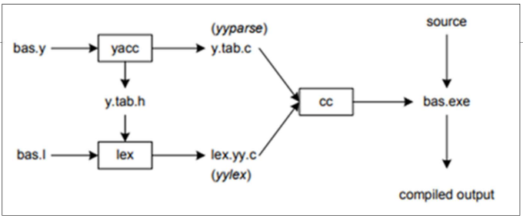
Step 1: An input file describes the lexical analyzer to be generated named lex.l is written in lex language. The lex compiler transforms lex.l to C program, in a file that is always named lex.yy.c.
Step 2: The C compiler compiles the lex.yy.c file into an executable file called a.out.
Step 3: The output file a.out takes a stream of input characters and produces a stream of tokens.
Program Structure:
Definition Section: The definition section contains the declaration of variables, regular definitions, manifest constants. In the definition section, text is enclosed in “%{ %}” brackets. Anything written in this brackets is copied directly to the file lex.yy.c

Rules Section: The rules section contains a series of rules in the form: pattern action and pattern must be unintended and action begins on the same line in {} brackets. The rule section is enclosed in “%% %%”.

User Code Section: This section contains C statements and additional functions. We can also compile these functions separately and load with the lexical analyzer.

%{
// Definitions
%}

%%
// Rules
%%

// User code section

How to run the program:
To run the program, it should be first saved with the extension .l or .lex. Run the below commands on the terminal in order to run the program file.

Step 1: flex filename.l or flex filename.lex depending on the extension file is saved with
Step 2: gcc lex.yy.c
Step 3: ./a.out
Step 4: Provide the input to program in case it is required

Note: Press Ctrl+D or use some rule to stop taking inputs from the user. Please see the output images of below programs to clear if in doubt to run the programs.

Code:
Count no of Vowels and Consonants:
%{
int count_v = 0, count_c = 0;
%}

%%
[a|e|i|o|u|A|E|I|O|U] {count_v++;}
[a-zA-Z] {count_c++;}
. ;
%%
int yywrap(void){
return 1;
}

int main(int argc, char *argv[]){
FILE *fp;
fp = fopen(argv[1], "r");
if(!fp){
printf("File not found\n");
return 1;
}
yyin = fp;
yylex();
fclose(fp);
printf("No of Vowels : %d, No of Consonants %d\n",count_v,count_c);
return 0;
}

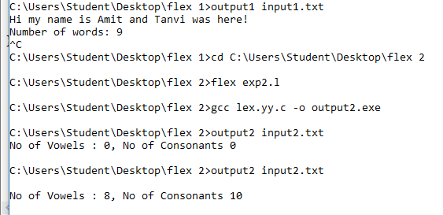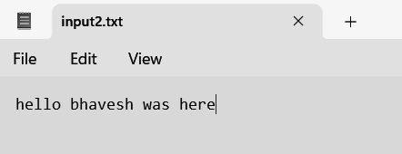

Count no of Words, characters & lines:
%{
#include <stdio.h>
int wordCount = 0;
int charCount = 0;
int lineCount = 0;
%}

%%
[a-zA-Z]+ {
wordCount++;
charCount += yyleng;
}
\n {
lineCount++;
charCount++;
}
. {
charCount++;
}
%%
int yywrap(void){
return 1;
}

int main() {
yylex();
printf("Number of words: %d\n", wordCount);
printf("Number of characters: %d\n", charCount);
printf("Number of lines: %d\n", lineCount);
return 0;
}
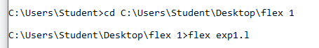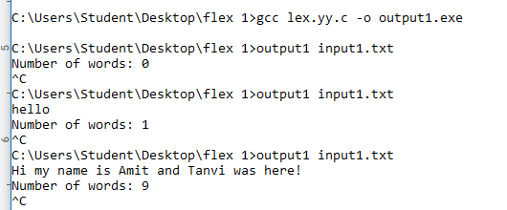

Count no of keywords,identifiers & operators:
%{
int count_kw = 0, count_id = 0 , count_op = 0;
%}

%%
[int|float|char|double|void|if|else|while|do|for|switch|case|break|continue] {count_kw++;}
[+|*|/|%|^|&|~|<=|>=|==|!=|=] {count_op++;}
[a-zA-Z][a-zA-Z0-9] {count_id++;}
. ;
%%
int yywrap(void){
return 1;
}

int main(int argc, char *argv[]){
FILE *fp;
fp = fopen(argv[1], "r");
if(!fp){
printf("File not found\n");
return 1;
}
yyin = fp;
yylex();
fclose(fp);
printf("Keywords: %d\nIdentifiers: %d\nOperators: %d\n", count_kw, count_id, count_op);
return 0;
}

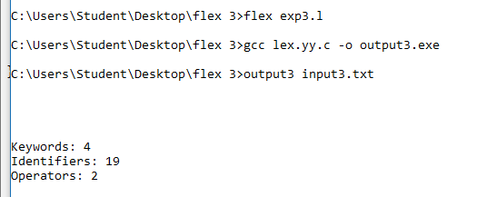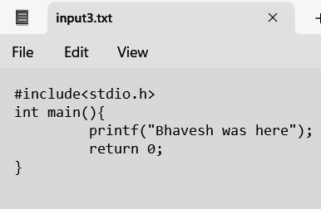

Identify Even & odd integers:
%{
#include <stdio.h>
int i;
%}

%%
[0-9]+ { i = atoi(yytext);
if(i%2==0)
printf("%d is even\n",i);
else
printf( "%d is odd\n",i);
}
. ;
%%
int yywrap(void){
return 1;
}

int main(int argc, char *argv[]){
yylex();
return 0;
}

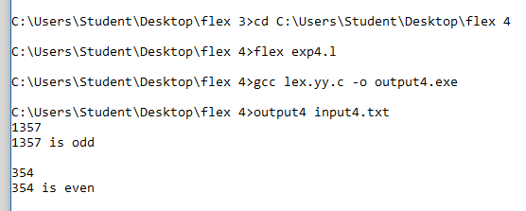

Count of printf & scanf statements in C program:
%{
int count_p = 0, count_s = 0;
%}

%%
"printf" {count_p++;}
"scanf" {count_s++;}
. ;
%%
int yywrap(void){
return 1;
}

int main(int argc, char *argv[]){
FILE *fp;
fp = fopen(argv[1], "r");
if(!fp){
printf("File not found\n");
return 1;
}
yyin = fp;
yylex();
fclose(fp);
printf( "Number of printf statements: %d\n", count_p);
printf( "Number of scanf statements: %d\n", count_s);
return 0;
}

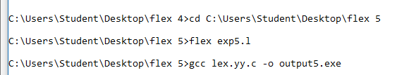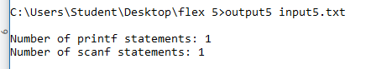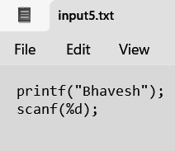

Classify English words as verbs, adverbs, adjectives etc.:
%{
#include <stdio.h>
#include <string.h>

int is_verb(char *word);
int is_adverb(char *word);
int is_adjective(char *word);
%}

%%
[a-zA-Z]+ {
printf("%s is a(n)", yytext);
if (is_verb(yytext))
printf(" verb.\n");
else if (is_adverb(yytext))
printf(" adverb.\n");
else if (is_adjective(yytext))
printf(" adjective.\n");
else
printf(" unknown word.\n");
}
.|\n /* Ignore any other characters */

%%

int is_verb(char *word) {
// Logic to check if the word is a verb
// For simplicity, let's assume all words ending in "ing" are verbs
int len = strlen(word);
if (len >= 3 && strcmp(word + len - 3, "ing") == 0)
return 1;
else
return 0;
}

int is_adverb(char *word) {
// Logic to check if the word is an adverb
// For simplicity, let's assume all words ending in "ly" are adverbs
int len = strlen(word);
if (len >= 2 && strcmp(word + len - 2, "ly") == 0)
return 1;
else
return 0;
}

int is_adjective(char *word) {
// Logic to check if the word is an adjective
// For simplicity, let's assume all words ending in "ous" are adjectives
int len = strlen(word);
if (len >= 3 && strcmp(word + len - 3, "ous") == 0)
return 1;
else
return 0;
}

int main() {
yylex();
return 0;
}

int yywrap() {
return 1; // Indicate end of input
}

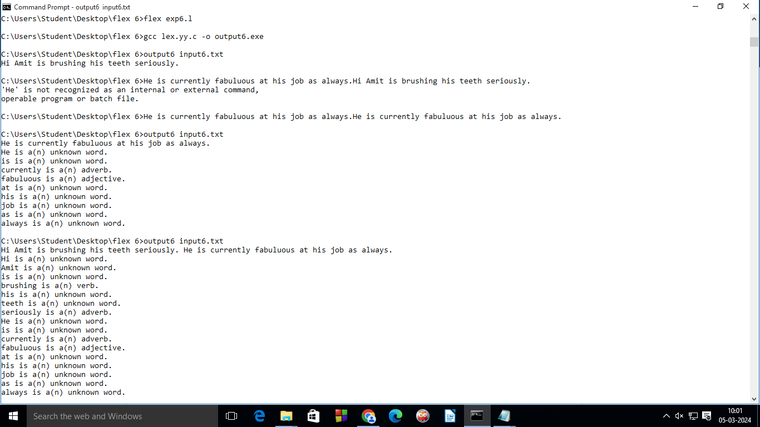
Conclusion:
In conclusion, the implementation of a Lex in C for scanning source code successfully demonstrated the fundamental role of Lex in compiler design. The program effectively identified and performed following tasks like Count no of Vowels & Consonants, Count no of Words, characters & lines, Count no of keywords,identifiers & operators, Identify Even & odd integers, Count of printf & scanf statements in C program and Classify English words as verbs, adverbs, adjectives. The outcome reinforces the importance of Lex in the overall compilation process.

